Town of Roanoke Water Quality Report 2022
PWSID# 5235009 June, 2022 Report No. 24
Important information for the Spanish-speaking population
Este informe contiene informacion muy importante sobre la calidad del agua potable que usted consume. Por fabor traduzcalo, o hable con alguien que lo entienda bien y pueda explicarle.

Is my drinking water safe?
Yes, our water meets all of EPA’s health standards. In 2021, we conducted tests for contaminants that may be in drinking water. As shown in the chart on the back, we found all those contaminants to be at safe levels, or below.

Is our water system meeting other rules that govern our operations?
The State and EPA require us to test and report on our water on a regular basis to ensure its safety. We have always met all of these requirements. We want you to know that we pay attention to all the rules.

What is the source of my water?
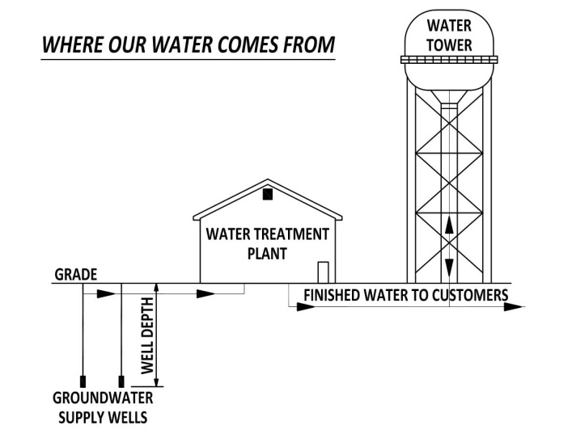
The Town’s drinking water comes from a groundwater source. Three wells are located west of Seminary Street (CR 400 East) at the Town’s water treatment plant site. A fourth well is located at Oak Park Dr. and Main St. The wells range in depth from 56 feet to 305 feet. The water is pumped from this groundwater source and treated for removal of impurities such as iron and manganese by aeration and filtration. It is then chlorinated and pumped into the water distribution system.

Why are there contaminants in my water?
The sources of drinking water (both tap and bottled water) include rivers, lakes, streams, ponds, reservoirs, springs and wells. As water travels over the surface of the land or through the ground, it dissolves naturally occurring minerals, and in some cases, radioactive material, and can pick up substances resulting from the presence of animals or from human activity.

Contaminants that may be present in source water include: microbial contaminants, such as viruses and bacteria, which may come from sewage treatment plants, septic systems, agricultural livestock operations and wildlife. Inorganic contaminants, such as salts and metals, which can be naturally occurring or result from urban stormwater runoff, industrial or domestic wastewater discharge, oil and gas production, mining or farming. Pesticides and herbicides: This may come from a variety of sources such as agricultural, storm water runoff and residential uses. Organic chemicals, including synthetic and volatile organic chemicals: which are by-products of industrial processes and petroleum production, and can also come from gas stations, urban storm water runoff and septic systems. Radioactive materials: which can be naturally occurring or be the result of oil and gas production and mining activities. Drinking water, including bottled water, may reasonably be expected to contain at least small amounts of some contaminants. The presence of contaminants does not necessarily indicate that water poses a health risk.

More information about contaminants and potential health effects can be obtained by calling the Environmental Protection Agency’s Safe Drinking Water Hotline (800-426-4791).

How can I get involved?
Your Town Council meets on the first and third Tuesday of each month at 6:00 p.m. Please feel free to participate at these meetings.

DO I NEED TO TAKE SPECIAL PRECAUTIONS?
Some people may be more vulnerable to contaminants in drinking water than the general population. Immuno-compromised persons such as persons with cancer undergoing chemotherapy, persons who have undergone organ transplants, people with HIV/AIDS or other immune system disorders, some elderly, and infants can be particularly at risk from infections. These people should seek advice about drinking water from their health care providers.

EPA/CDC guidelines on appropriate means to lessen the risk of infection by Cryptosporidium and other microbiological contaminants are available from the Safe Drinking Water Hotline (800-426-4791).

Other Information
IDEM has approved our Wellhead Protection Plan. This plan helps increase awareness of proper waste disposal, to further protect the source of our drinking water.

For more information about your drinking water:
Please call us at 672-8948 or 672-8116

Town of Roanoke Quality Report 2021 Report No. 24
Water Quality Data
What does this chart mean?
- MCLG: Maximum Contaminant Level Goal, or the level of a contaminant in drinking water below which there is no known or expected risk to health. MCLGs allow for a margin of safety.
- MCL: Maximum Contaminant Level, or the highest level of a contaminant that is allowed in drinking water, MCLs are set as close to the MCLGs as feasible using the best available treatment technology.
- NOTE: The EPA requires monitoring of over 80 drinking water contaminants. Those listed below are the only contaminants detected in your drinking water. For a complete list, contact the Town Hall.

Contaminant (units) | MCLG | MCL | Highest Level Found | Violation | Typical Source of Contaminant
Microbial Contaminants
Total Coliform  % positive samples | 0 | Presence of coliform bacteria in two monthly samples | 0 | 0 | Naturally present in human & animal fecal waste.
Total Trichalomethane ppb | N/A | 80 | 41 | 0 | Byproduct of drinking water disinfection.
Total Haloacetic Acids ppb | N/A | 60 | 16 | 0 | Byproduct of drinking water disinfection.
Inorganic Compounds and Contaminants
Antimony ppm | 0.006 | 0.006 | <0.0005 (2017) | 0 | Discharge from petroleum refineries; fire retardants; ceramics, electronics, solder
Arsenic ppm | 0 | 0.010 | <0.0012 (2017) | 0 | Erosion of natural deposits
Barium ppm | 2 | 2 | 0.0723(2020) | 0 | Corrosion of household plumbing systems, erosion of natural deposits, leaching from wool preservatives
Nitrite + Nitrate ppm | 10 | 10 | <.05 | 0 | Runoff from fertilizer use; Leaching from septic tanks, sewage; erosion of natural deposits
Cyanide ppm | 0.2 | 0.2 | <0.020 (2017) | 0 | Discharge from industrial chemical factories
Fluoride (natural) ppm | 4 | 4 | 1.1 (2011) | 0 | Erosion of natural deposits, water additive which promotes strong teeth
Sodium ppm | N/A | N/A | 17.8 (2017) | 0 | Erosion of natural deposits

SOC’s (Synthetic Organic Compounds in Drinking Water) – None were detected in any samples
___________________________________________________________________________________________________________________
Special Note on Lead: If present, elevated levels of lead can cause serious health problems, especially for pregnant women and young children. Lead in drinking water is primarily from materials and components associated with service lines and home plumbing. Our system is responsible for providing high quality drinking water but cannot control the variety of materials used in plumbing components. When your water has been sitting for several hours, you can minimize the potential for lead exposure by flushing your tap for 30 seconds to 2 minutes before using water for drinking or cooking. If you are concerned about lead in your water, you may wish to have your water tested. Information on lead in drinking water, testing methods, and steps you can take to minimize exposure is available from the safe Drinking Water Hotline or at http://www.epa.gov/safewater/lead .

Abbreviations: · ppb: parts per billion or micrograms per liter · ppm: parts per million or milligrams per liter · mg/L: Picocuries per liter, a measure of radiation - N/A.: not applicable · ND: None Detected · AL: Action Limit, or the concentration of a contaminant which, when exceeded, is not a violation but can trigger treatment or other requirements which a water system must follow.

About the data: Some of the data presented in this table are from testing done during 2020 or earlier. We monitor for some contaminants less than once per year, and for those contaminants, the date of the last sample is shown in the table.

Town of Roanoke Quality Report 2021 Report No. 24

Additional Water Quality Information

Lead and Copper | Date Sampled | MCLG | Action Level (AL) | 90th Percentile | # Sites Over  AL | Units | Violation | Likely Source of Contamination
Copper | 2021 | 1.3 | 1.3 | .21 | 0 | ppm | N | Erosion of natural deposits; Leaching from wood preservatives; Corrosion of household plumbing

Lead | 2021 | 0 | 15 | 7.8 | 1 | ppb | N | Corrosion of household plumbing systems; erosion of natural deposits

Radioactive Contaminants | Collection Date | Highest Level Detected | Range of Levels Detected | MCLG | MCL | Units | Violation | Likely Source of Contamination
Beta/photon emitters | 10/16/2017 | 3.4 | 3.4-3.4 | 0 | 4 | Mrem/yr | N | Decay of natural and manmade deposits
Gross alpha excluding radon and uranium | 10/16/2017 | 1.5 | 1.5-1.5 | 0 | 15 | pCI/L | N | Erosion of natural deposits
Uranium | 10/16/2017 | .6639 | .6639-.6639 | 0 | 30 | ug/L | N | Erosion of natural deposits

Revised Total Coliform Rule (RTCR)
The Revised Total Coliform Rule (RTCR) seeks to prevent waterborne diseases caused by E. coli. E. coli are bacteria whose presence indicates that the water may be contaminated with human or animal wastes. Human pathogens in these wastes can cause short-term effects, such as diarrhea, cramps, nausea, headaches, or other symptoms. They may pose a greater health risk for infants, young children, the elderly.
Violation Type | Violation Begin | Violation End | Violation Explanation
MONITORING, ROUTINE, MINOR (RTCR) | 07/01/2021 | 07/31/2021 | We failed to test our drinking water for the contaminant and period indicated. Because of this failure, we cannot be sure of the quality of our drinking water during the period indicated.
Report Sample Results/Fail Monitor  (RTCR) | 08/01/2021 | 08/30/2021 | We failed to submit sample results or report failure to test drinking water  *Both violations were the result of the lab not sending IDEM the information in a timely manner. Both samples passed the required tests

